Random Forest
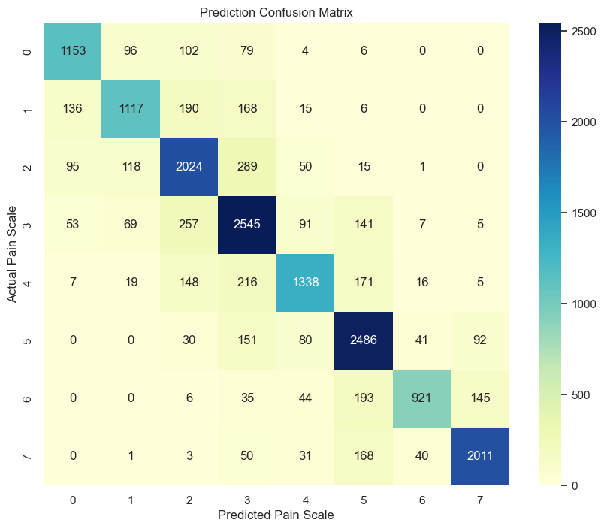

Full Metrics Report:
precision recall f1-score support

1 0.80 0.80 0.80 1440
2 0.79 0.68 0.73 1632
3 0.73 0.78 0.76 2592
4 0.72 0.80 0.76 3168
5 0.81 0.70 0.75 1920
6 0.78 0.86 0.82 2880
7 0.90 0.69 0.78 1344
8 0.89 0.87 0.88 2304

accuracy 0.79 17280
macro avg 0.80 0.77 0.78 17280
weighted avg 0.79 0.79 0.79 17280
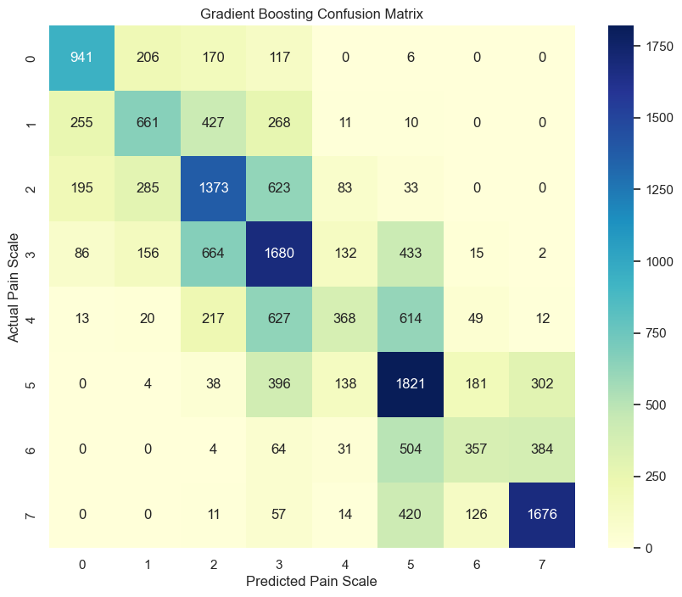
Full Metrics Report:
precision recall f1-score support

1 0.63 0.65 0.64 1440
2 0.50 0.41 0.45 1632
3 0.47 0.53 0.50 2592
4 0.44 0.53 0.48 3168
5 0.47 0.19 0.27 1920
6 0.47 0.63 0.54 2880
7 0.49 0.27 0.34 1344
8 0.71 0.73 0.72 2304

accuracy 0.51 17280
macro avg 0.52 0.49 0.49 17280
weighted avg 0.51 0.51 0.50 17280
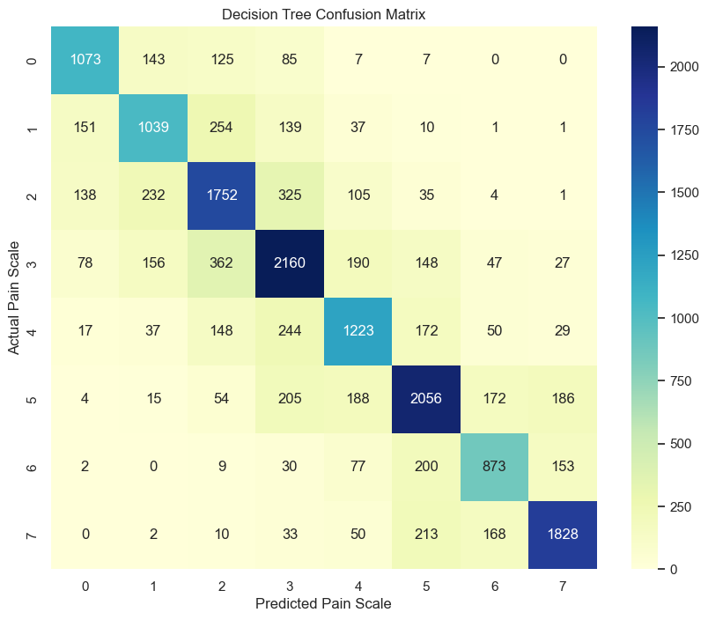

Full Metrics Report:
precision recall f1-score support

1 0.73 0.75 0.74 1440
2 0.64 0.64 0.64 1632
3 0.65 0.68 0.66 2592
4 0.67 0.68 0.68 3168
5 0.65 0.64 0.64 1920
6 0.72 0.71 0.72 2880
7 0.66 0.65 0.66 1344
8 0.82 0.79 0.81 2304

accuracy 0.69 17280
macro avg 0.69 0.69 0.69 17280
weighted avg 0.70 0.69 0.69 17280
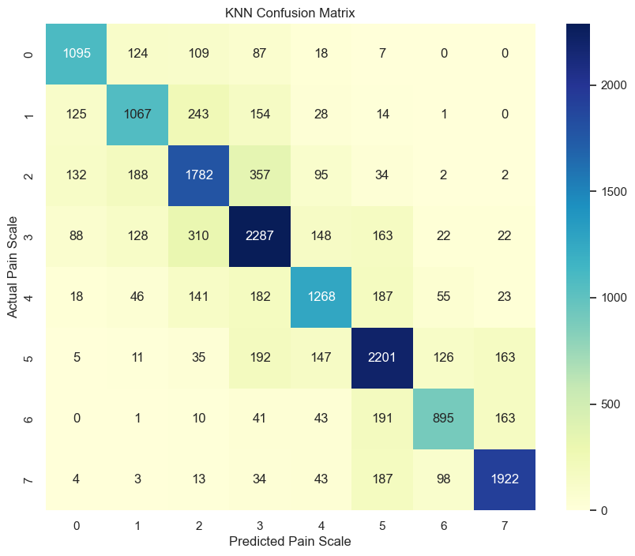

Full Metrics Report:
precision recall f1-score support

1 0.75 0.76 0.75 1440
2 0.68 0.65 0.67 1632
3 0.67 0.69 0.68 2592
4 0.69 0.72 0.70 3168
5 0.71 0.66 0.68 1920
6 0.74 0.76 0.75 2880
7 0.75 0.67 0.70 1344
8 0.84 0.83 0.84 2304

accuracy 0.72 17280
macro avg 0.73 0.72 0.72 17280
weighted avg 0.72 0.72 0.72 17280
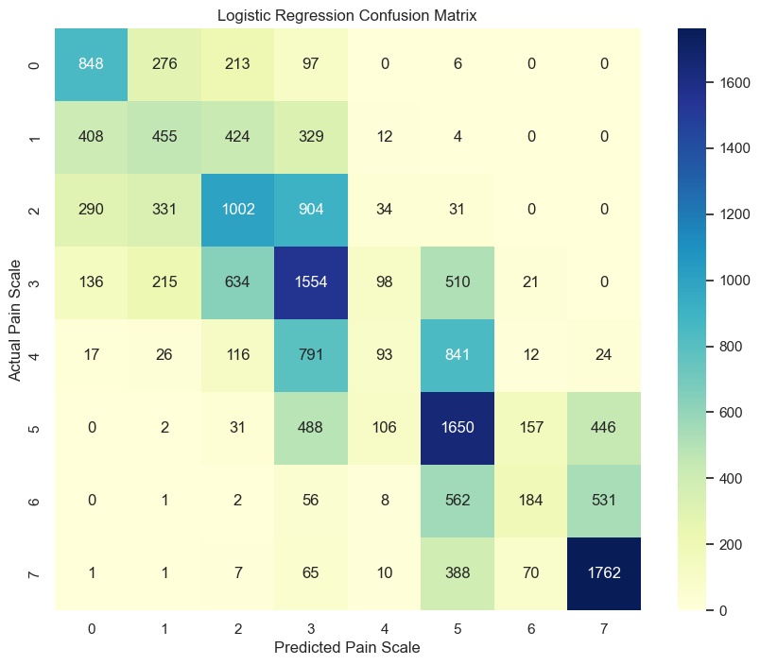
Full Metrics Report:
precision recall f1-score support

1 0.50 0.59 0.54 1440
2 0.35 0.28 0.31 1632
3 0.41 0.39 0.40 2592
4 0.36 0.49 0.42 3168
5 0.26 0.05 0.08 1920
6 0.41 0.57 0.48 2880
7 0.41 0.14 0.21 1344
8 0.64 0.76 0.70 2304

accuracy 0.44 17280
macro avg 0.42 0.41 0.39 17280
weighted avg 0.42 0.44 0.41 17280
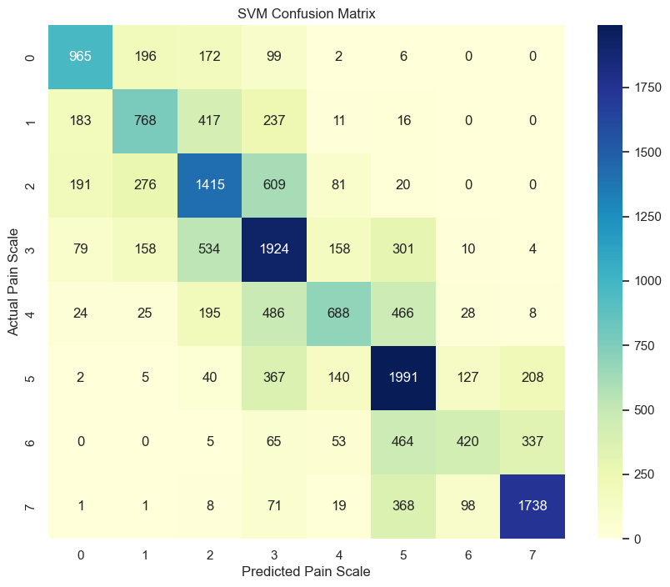
Full Metrics Report:
precision recall f1-score support

1 0.67 0.67 0.67 1440
2 0.54 0.47 0.50 1632
3 0.51 0.55 0.53 2592
4 0.50 0.61 0.55 3168
5 0.60 0.36 0.45 1920
6 0.55 0.69 0.61 2880
7 0.61 0.31 0.41 1344
8 0.76 0.75 0.76 2304

accuracy 0.57 17280
macro avg 0.59 0.55 0.56 17280
weighted avg 0.58 0.57 0.57 17280

